# Project Documentation: Pizza Sales Dashboard in Power BI

Introduction

This project involves creating a sales dashboard using Power BI to analyze pizza sales data. The dataset contains various columns including **pizza_id, order_id, pizza_name_id, quantity, order_date, order_time, unit_price, total_price, pizza_size, pizza_category,** and **pizza_name**. The data was imported from a PostgreSQL database and underwent cleaning and transformation processes. The dashboard provides insights into sales performance, trends, and product analysis.

Objective

The objective of this project is to create an interactive dashboard that enables users to visualize and analyze pizza sales data effectively. The dashboard should provide key metrics, trends, and insights to support decision-making processes for stakeholders.

Project Steps

Data Import and Cleaning

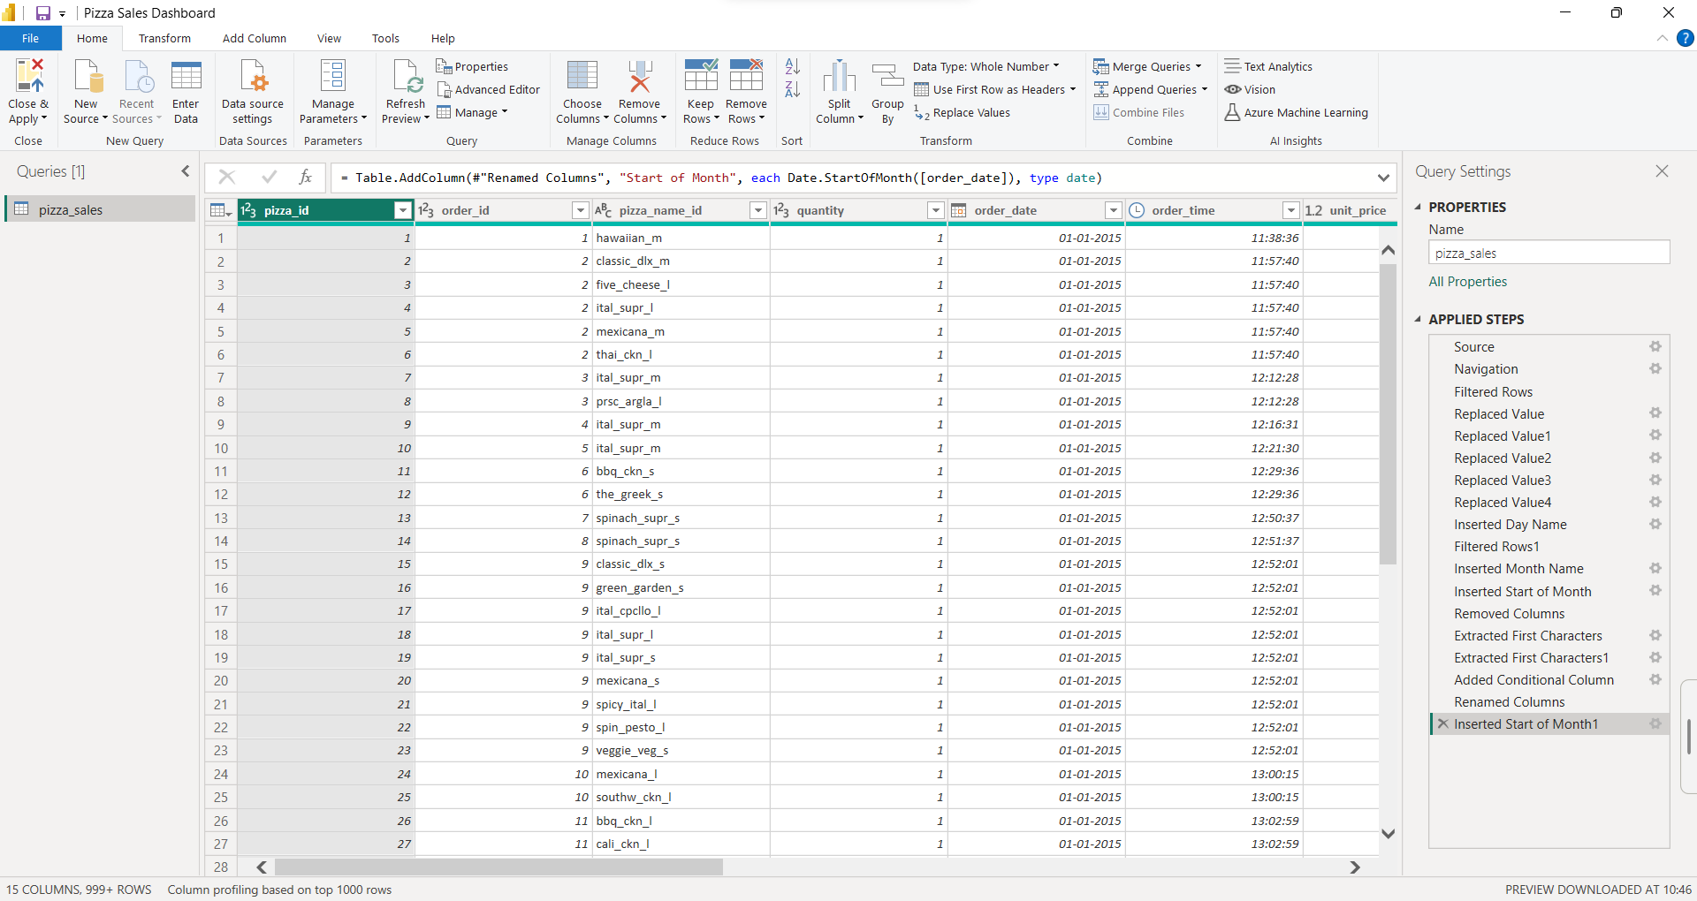

* Imported data from PostgreSQL database.
* Conducted data cleaning processes including:
  + Replacing values.
  + Updating table names.
  + Creating conditional columns.
  + Extracting year from the **order_date** column.

Data Modeling

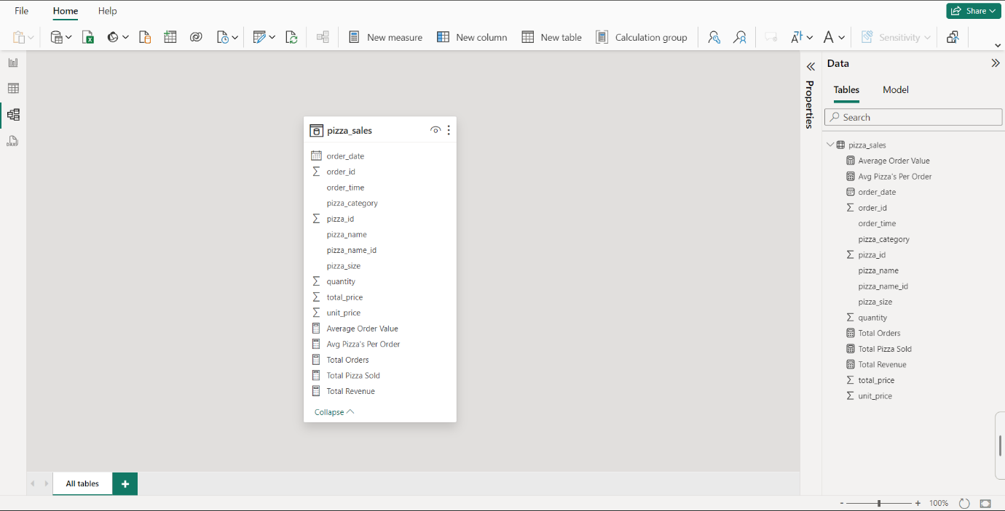

* Assembled the cleaned data into a single table for analysis.
* Utilized DAX (Data Analysis Expressions) to create measures including:
  + Total revenue.

Total Revenue = SUM(pizza_sales[total_price])

* + Total orders.

Total Orders = DISTINCTCOUNT(pizza_sales[order_id])

* + Average order quantity.

Avg Pizza's Per Order = DIVIDE( [Total Pizza Sold],[Total Orders])

* + Average order value.

Average Order Value = [Total Revenue]/[Total Orders]

* + Total Pizzas Sold.

Total Pizza Sold = SUM(pizza_sales[quantity])

3. Data Visualization

* Utilized various Power BI visuals including:
  + Advanced card visuals for displaying key metrics.

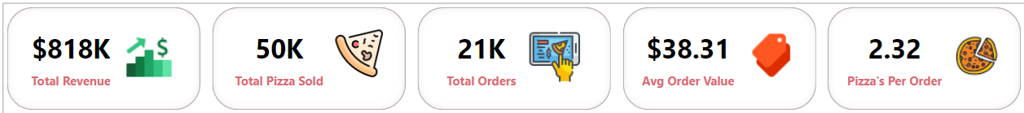

* + Column chart to visualize orders by day.

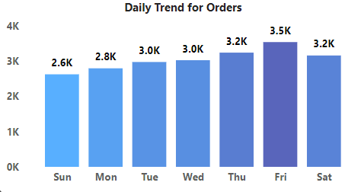

* + Line chart to display monthly sales trend.

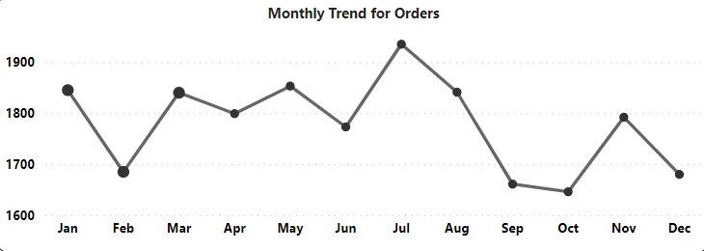

* + Donut charts to represent the percentage of orders by category and revenue.

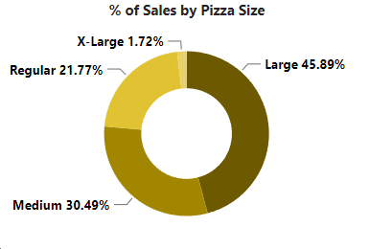­­­­

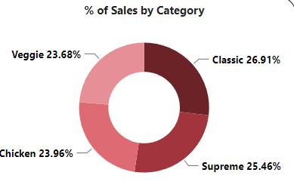

* + Matrix visual to showcase top 5 best/worst-selling pizzas.

4. Interactivity and Navigation

* Implemented slicers to enable filtering of visuals.
* Added buttons for navigation across pages.
* Integrated Power BI advanced chart called Key Influencers for further analysis.

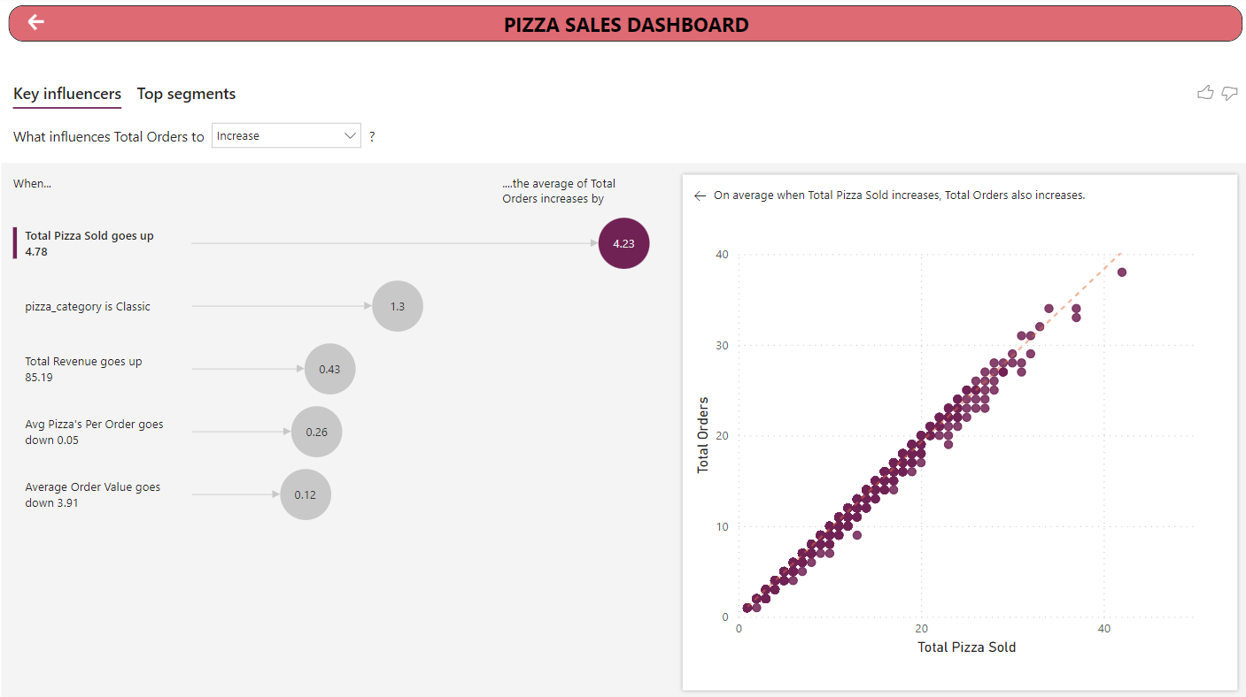

* Created custom tooltips to provide additional context to visuals.

Conclusion

The Pizza Sales Dashboard in Power BI offers a comprehensive analysis of pizza sales data, providing stakeholders with valuable insights into sales performance, trends, and product analysis. The dashboard's interactive features facilitate dynamic exploration of the data, empowering users to make informed decisions and drive business growth.

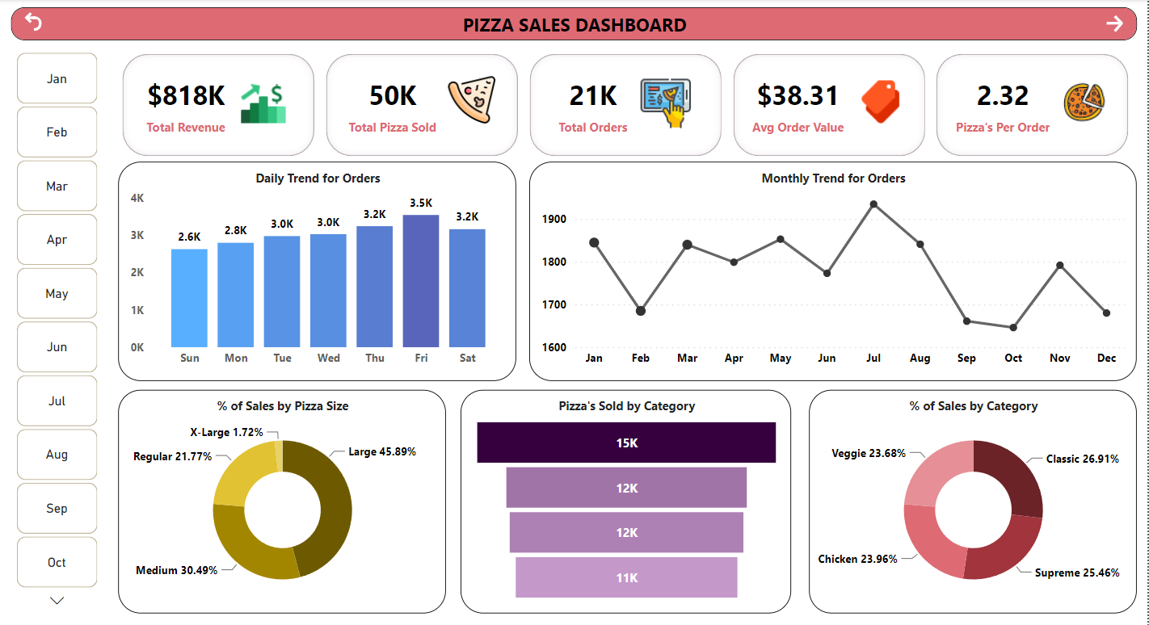

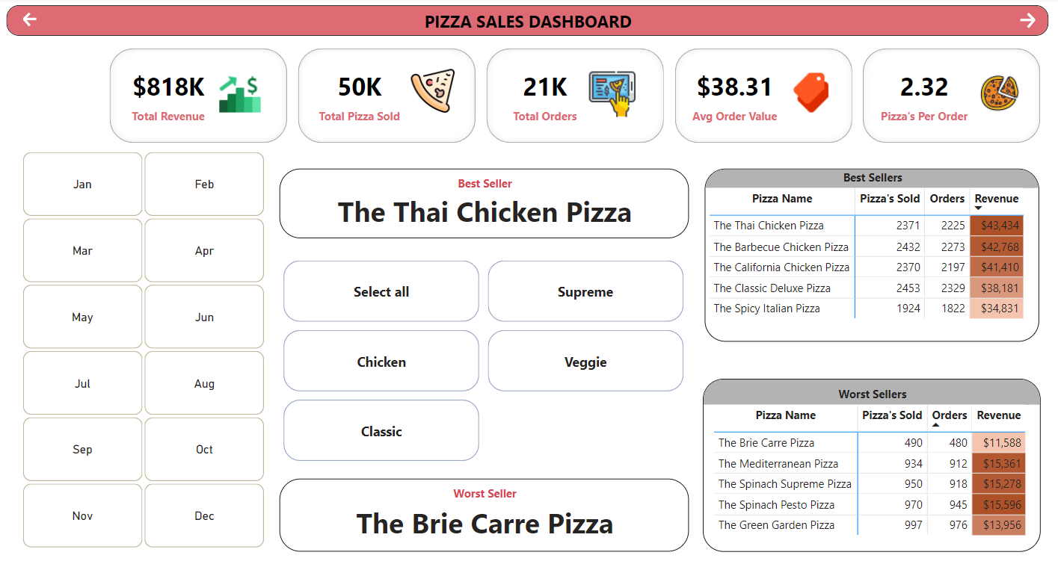

Future Enhancements

* Incorporate additional data sources for comprehensive analysis.
* Implement predictive analytics for forecasting sales.
* Enhance visualization aesthetics for improved user experience.
* Integrate with real-time data for up-to-date insights.
* Collaborate with stakeholders to gather feedback and iterate on dashboard improvements.

This documentation provides an overview of the Pizza Sales Dashboard project in Power BI, outlining its objectives, steps, and potential areas for future enhancement.